NATIONAL SKILL TRAINING INSTITUTE

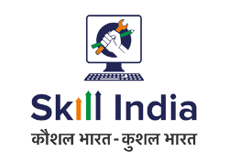**DATE-16/09/2025**

**National Skill Training Institute (NSTI)**

The National Skill Training Institute (NSTI) stands as a cornerstone in India's mission to empower its youth with industry-relevant skills and vocational training. Operating under the Ministry of Skill Development and Entrepreneurship, NSTIs are spread across the country and play a vital role in bridging the gap between education and employability.

**🌟 Vision and Mission**

NSTI’s primary goal is to provide high-quality technical and vocational education to individuals, enabling them to become skilled professionals in various trades. The institute aims to foster self-reliance, entrepreneurship, and economic participation, especially among women and marginalized communities.

**🛠️ Courses and Training**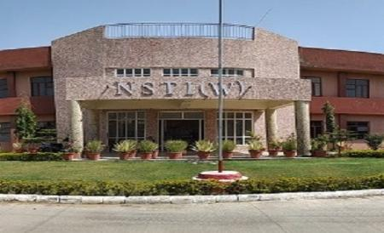

NSTIs offer a wide range of programs including:

* Craftsmen Training Scheme (CTS)
* Craft Instructor Training Scheme (CITS)
* Short-Term Skill Courses
* Advanced Vocational Training Programs

These courses are designed to meet the evolving demands of industries such as electronics, IT, welding, electrical engineering, and more. The curriculum is regularly updated to incorporate the latest technological advancements and industry practices.

**👩‍🔧 Women Empowerment**

NSTI (W) Bengaluru, for example, was established in 1977 specifically to enhance women's participation in the workforce. It provides equitable opportunities for skill development, helping women gain employment or start their own ventures.

**🤝 Industry Collaboration**

NSTIs maintain strong linkages with industries to ensure that training remains relevant and job-oriented. Apprenticeship programs and job fairs are regularly organized to connect trainees with potential employers.

**📈 Impact and Future**

NSTIs have significantly contributed to India’s skilling ecosystem by producing thousands of trained professionals annually. As India moves toward becoming a global manufacturing and service hub, NSTIs will continue to play a crucial role in preparing a future-ready workforce.

Would you like help tailoring this essay for a specific audience—like a school assignment, college application, or speech? I can also translate it into Hindi or another language if you’d prefer.